Established leaf flavonoids as phytoligands from Andrographis paniculata (Burm. f.) Wall. Ex Neesfor antibacterial activity against bacterial DNA-gyrase b receptor: An in silico approach
Debojyoti Roychowdury^{1*}, Partha Talukdar² and Soumendra Nath Talapatra³
¹Department of Biochemistry, Techno India University, Salt Lake, Kolkata ,India.
²Department of Botany, Serampore College,
University of Calcutta, William Carey Road, Serampore,
West Bengal, India

³Department of Biological Science, Seacom Skills University,
Kendradangal, Shantiniketan, Birbhum – 731236, West Bengal, India
*Corresponding author: Debojyoti Roychowdhury phone: +91-9113134132 email: roychowdhury.debojyoti@gmail.com
ABSTRACT
The medicinal plant,Andrographis paniculata(Burm. f.) Wall. Ex Neesis a common herbal plant having several medicinal properties in the leaves of plant.The medicinal properties are depending upon by the presence of several phytochemicals. Among different medicinal values,potent antibacterial properties are known as natural antibacterial agents. The objective of the present study was to detect receptor-ligand binding energy and interaction through molecular docking for lead phytocompounds established in the leaf of A. paniculata against bacterial DNA gyrase B protein (PDB ID: 3G7B). Molecular docking was performed by usingsoftware (iGEMDOC, Version 2.1) to detect binding energy and interaction.The interaction with residues was visualized in the AutoDoc tool (Version 1.5.6). Among 9 phytochemicals and 1 antibiotic (Ciprofloxacin), highest binding energy value was obtained in 5-hydroxy-7,8,2',5'-tetramethoxy-flavone (-121.862 Kcal/mol) when compared to Ciprofloxacin (-106.621Kcal/mol). The binding interaction of target protein with this phytocompound found binding at the active site due to competitive inhibition. In conclusion, phytocompound 5-hydroxy-7,8,2',5'-tetramethoxy-flavone can be alternative of synthetic antibacterial drug as per binding energy value and residue interaction. It is suggesting further pharmacological and toxicological assay with this phytocompound after isolation from medicinal plant (A. paniculata).
Keywords:Medicinal plant;A.paniculata; Phytocompounds; Bacterial DNA gyrase B; Molecular docking; Receptor-ligand binding; In silico prediction

INTRODUCTION
The medicinal herb, Andrographis paniculata(Burm. f.) Wall. Ex Neesis a common plant speciescontaining several phytochemicals in the leaves of plant to prevent different diseases. Among several diseases, natural product from this plant is showing research interest to detect lead compounds for the prevention of bacterial infection. On the other hand, it was observed that bacterial resistance occurred by synthetic antibiotic during the prevention of infection but phytocompounds of plant species can be suitable antibacterial drugs and prevent infection without bacterial resistance^{.[1,2,3,4]}
It has been studied by many researchers that different form of crude plant extract of A. paniculataprevent bacterial infection caused bySalmonella sp., Shigellasonnei, Escherichia coli, gram A streptococci, and Staphylococcus aureus, Pseudomonas aeruginosa, methicillin resistant S. aureus, Salmonella typhimurium, Streptococcus pneumonia, Streptococcus pyogenes, Legionella pneumophila, Bordetella pertussis, etc. ^{[5,6,7]}. In present scenario it is interesting research to predict the lead compound(s) as single or combination of phytochemical(s) through virtual screening. Furthermore, experimentation with several phytocompounds after extraction from leaves is a tedious job along with time and cost involvement, etc.
In this regard, computer-based receptor-ligand binding as a suitable approach for structure-based drug or biopesticide screening and exact phytocompound or combinations of few phytochemicals can be predicted within a few hours by using computational simulation.^{[8]}It is well-known that the molecular docking tool is used to predict the interaction between a small molecule (ligand) and a macromolecule (protein) that describes the behavioural characterization of small molecules in the binding site of target receptor. From past to recent research, several researchers have been reported the importance of molecular docking. ^{[8-21]}

In recent researchnatural products are potential for the development ofbiopesticides. Antibiotic is an important drug to prevent various bacterial infection in plants and animals. Several researchers are investigatingthe inhibitory activities to preventthe multiplication of pathogenic bacteria. Among several enzymes in bacteria, DNA gyrase enzyme is most effective for metabolic regulation in bacteria and help in the process of DNA replication,and called as type II topoisomerase, which enhance bacterial multiplication.^{[22-25]}
The present objective was to detect suitable receptor-ligand binding energy and molecular interaction through molecular docking approach for phytocompounds established in A. paniculata against bacterial DNA gyrase B protein (PDB ID: 3G7B).

MATERIALS AND METHODS
Protein or receptorselection

The crystal three-dimensional (3-D)structure of receptorknown as bacterial DNA gyraseB (PDB ID: 3G7B) was retrieved from protein data bank (http:www.rcsb.org/) as per validation report. After experimentation,²⁶have deposited the X-ray diffraction crystallographic structure of the bacterial DNA gyraseB (Staphylococcus aureus gyrase B co-complex with methyl ({5-[4-(4-hydroxypiperidin-1-Yl)-2-phenyl-1,3-thiazol-5-Yl]-1H-pyrazol-3-Yl}methyl)carbamateinhibitor) at 2.30Å resolution.The 3-D ribbon structure was visualized in AutoDocktool developed by The Scripps Research Institute (Morris et al., 1998)²⁷ andis exhibited in Fig 1.
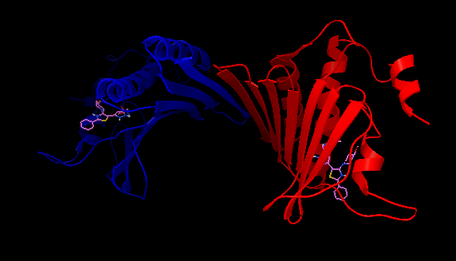
Fig 1. 3-D ribbon structure of DNA gyraseB(PDB ID: 3G7B) [Chain A = blue colour attached with ligand (ball and stick structure in green) at 471 position and Chain B = red colour attached with ligand (ball and stick structure in green) at 472]
Phyto and synthetic ligandsselection
The selection of phytochemicals (ligands) were done from the literatures as per antibacterial properties (Chen et al., 2006; Jarukamjorn and Nemoto, 2008)28,29,30. In the present study, established 9 phytochemicals (flavonoids) of A. paniculatareported as antibacterial agents and one synthetic compound as known antibiotic (ciprofloxacin) were taken. The Canonical SMILES of these compounds were retrieved from the PubChem database (www.ncbi.nlm.nih.gov/pubchem) and .pdb file of each phytochemical was obtained from CORINA online server (www.mn-am.com/).

Molecular docking and interactionstudy
The molecular docking was performed to know targetleadby using iGEMDOCK (Version 2.1) developed by Yangand Chen (2004)31. Thereceptor-ligandinteraction provides the values of binding energy,electrostatic, hydrogen-bonding and van der Waals after completed docking.The above-mentioned profiles and compound structures were obtained by drug screening method for selected ten ligands as per genetic algorithm parameter by setting population size of 200along with 70 generations and 3 solutions. After thecompletion of the docking, the post docking analysis wasperformed to find the docking pose and its energy values.The molecular docking was visualized by using AutoDoc tool, developed by The Scripps Research Institute and the results of three-dimensional structure were depicted. Docking of 9 phytochemicals and ciprofloxacin (ligand) with bacterial DNA gyrase B protein (PDB ID: 3G7B) were analysed to detect suitable binding energy value. The present tool predicts docking result by obtaining energy value for each ligand. Finally, all ten ligands were analysed to detect binding position and energy value. The resultant structural complexes of the individual ligand/receptor binding were finally recorded to determine some specific contacts between the atoms of the test compounds and amino acids of the DNA gyrase B protein. In the post-screening analysis, hydrogen bonding value, van der Waal and electrostatic forces were obtained to know the efficiency of protein-ligand interaction clustering.

RESULTS AND DISCUSSION
Present computational prediction(molecular docking) indicates that favourable binding energy was observed in 5-hydroxy-7,8,2',5'-tetramethoxy-flavone (-121.862 Kcal/mol) when compared to Ciprofloxacin (-106.621Kcal/mol),among other flavonoids of A. paniculata. In case of other flavonoids, the binding energy values (Kcal/mol) of all 9 flavonoids such as Andrographolide (-116.083), Andrographidine C (-116.083), 7-O-methylwogonin (-110.152), 5,7,3',4'-tetrahydroxyflavone (-109.642), 5,7,4'-trihydroxyflavone (-102.227), 7-O-methyldihydrowogonin (-95.3081), Neoandrographolide (-91.8332) and 14-Deoxyandrographolide (-84.1036) respectively (Table 1).
In case of interaction study, theclose contact residues such as ILE51, ILE175, THR173, ILE86, ASP81, GLY85, ARG84 and GLU58 and one hydrogen bond contact residue as ASN54 in chain A were obtained for 5-hydroxy-7,8,2',5'-tetramethoxy-flavone while the contact residues such as PRO87, ILE86, THR173, GLY, 85, ASP84, ARG84, GLU58 and ASN54 in chain A without hydrogen bond contact were observed for Ciprofloxacin (Fig 2). On the other hand, the eight studied flavonoids were also observed the binding interaction with contact residues and hydrogen bonding (Fig 3). ForAndrographolideand Andrographidine C, thecontact residues such as ILE51,ASN54, GLU58, ARG84, ARG144, GLY85,ASP81,ILE86 andTHR173 and four hydrogen bond contacts,one with SER55 and others with inhibitory molecule (B471) in chain A were observed. For 7-O-methylwogonin, ILE51, ASN54, GLU58, ARG84,THR173,ILE86, PRO87, ILE175 and ILE102as contact residues and two hydrogen bond contacts, one with GLY85 and other with inhibitory molecule (B471) in chain A were observed. For 5,7,3',4'-tetrahydroxyflavone, thecontact residues such as ILE51, GLU58, ARG84, ASP81, GLY85,ILE86, THR173 and ILE175 and one hydrogen bond contact with ASN54in chain A were observed.For 5,7,4'-trihydroxyflavone, the contact residues such as ILE51, ILE175, THR173, ASP81, ILE86, GLY85, GLU58 and hydrogen bonding with ASN54 in chain A were obtained.For 7-O-methyldihydrowogonin, the contact residues such as ASP87, GLU58,ASP81,THR173 and ILE175and one hydrogen bond contact with ASN54 in chain A were observed. For 14-Deoxyandrographolide, the contact residues such as ASP57, SER55, GLU58,ARG84,THR173, ILE86, PRO87, ILE175 andASN54 and one hydrogen bond contact with inhibitory molecule (B471) in chain A were observed.For Neoandrographolide, the contact residues such as ASN54, SER55, GLU58, THR173,GLY85, ILE86, ILE102, SER128 and hydrogen bonding with inhibitory molecule in chain A were obtained.
Table 1. Interaction profiles of selected ligands of A. paniculataand known antibiotic after docking against bacterial DNA gyrase B receptor
Sl. No. | Ligands | Binding energy (Kcal/mol) | vander Waals value | Hydrogen bonding value | Electrostatic  Bonding value
Phytochemicals
1. | 5-hydroxy-7,8,2',5'-tetramethoxy-flavone | -121.862 | -97.2159 | -24.6463 | 0
2. | Andrographolide | -116.083 | -98.4045 | -17.6786 | 0
3. | Andrographidine C | -116.039 | -98.1866 | -17.8523 | 0
4. | 7-O-methylwogonin | -110.152 | -89.9666 | -20.1858 | 0
5. | 5,7,3',4'-tetrahydroxyflavone | -109.642 | -81.6725 | -27.9695 | 0
6. | 5,7,4'-trihydroxyflavone | -102.227 | -85.8295 | -16.3975 | 0
7. | 7-O-methyldihydrowogonin | -95.3081 | -81.6637 | -13.6443 | 0
8. | Neoandrographolide | -91.8332 | -70.3942 | -21.439 | 0
9. | 14-Deoxyandrographolide | -84.1036 | -59.3194 | -24.7842 | 0
Synthetic chemical
10. | Ciprofloxacin | -106.621 | -92.681 | -15.9616 | 2.02182

It was reported in earlier studies that active site residues are found in DNA gyrase B such as GLU50, ASN54, GLU58 and THR173 present in the ATP binding pocket, which are involved in ATPase activity (Gross et al., 2003; Jagadeesan et al., 2015)32,33.In present prediction withtheflavonoid phytoligand (5-hydroxy-7,8,2',5'-tetramethoxy-flavone), and synthetic ligand (Ciprofloxacin)both were found binding to the active site in chain A of bacterial DNA gyrase B (PDB ID: 3G7B). But phytoligand5-hydroxy-7,8,2',5'-tetramethoxy-flavoneshowed highest binding energy among other studied flavonoids, which may be due to competitive inhibition. In another research work, it was observed that phytoligandEpigallocatechin-3-gallate higher activity to inhibited bacterial DNA gyrase B by interaction with its ATP binding site and these catechins are containing in green tea (Gradišar et al., 2007)34.According to Barik and Talukdar (2018),35 phytoligandas flavonoid Epigallocatechin-3-gallate showed highest binding energy and binding opposite side of the active site due to non-competitive inhibition.Although, researchers documented in experimental study that the crude extract of A. paniculata is well-known antibacterial agentbutthe function of exact phytocompound in antimicrobial activity is unknown. The selection of phytochemicals of A. paniculatain the present computational predictionon the basis of literatures supported secondary metabolites especially flavonoids have already been investigated as antibacterial natural compound .
The interaction profile of post-screening analysis for protein-ligand complexes showed for receptor-ligand binding efficiency and hierarchical tree representation for the compound similarities as obtained through the present tool (Fig 4).
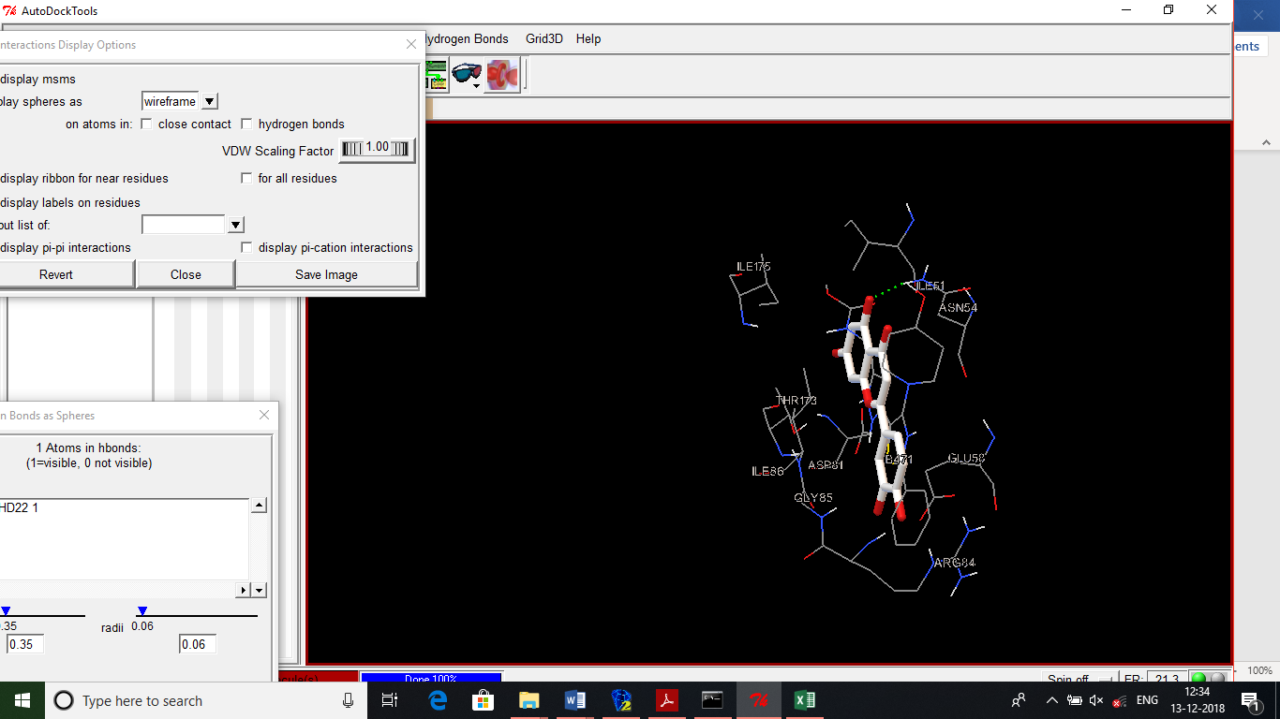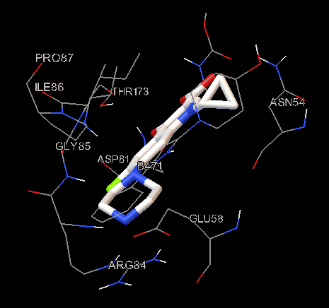
Fig 2. 5-hydroxy-7,8,2’,5’-tetramethoxy-flavone and Ciprofloxacindocking interactions
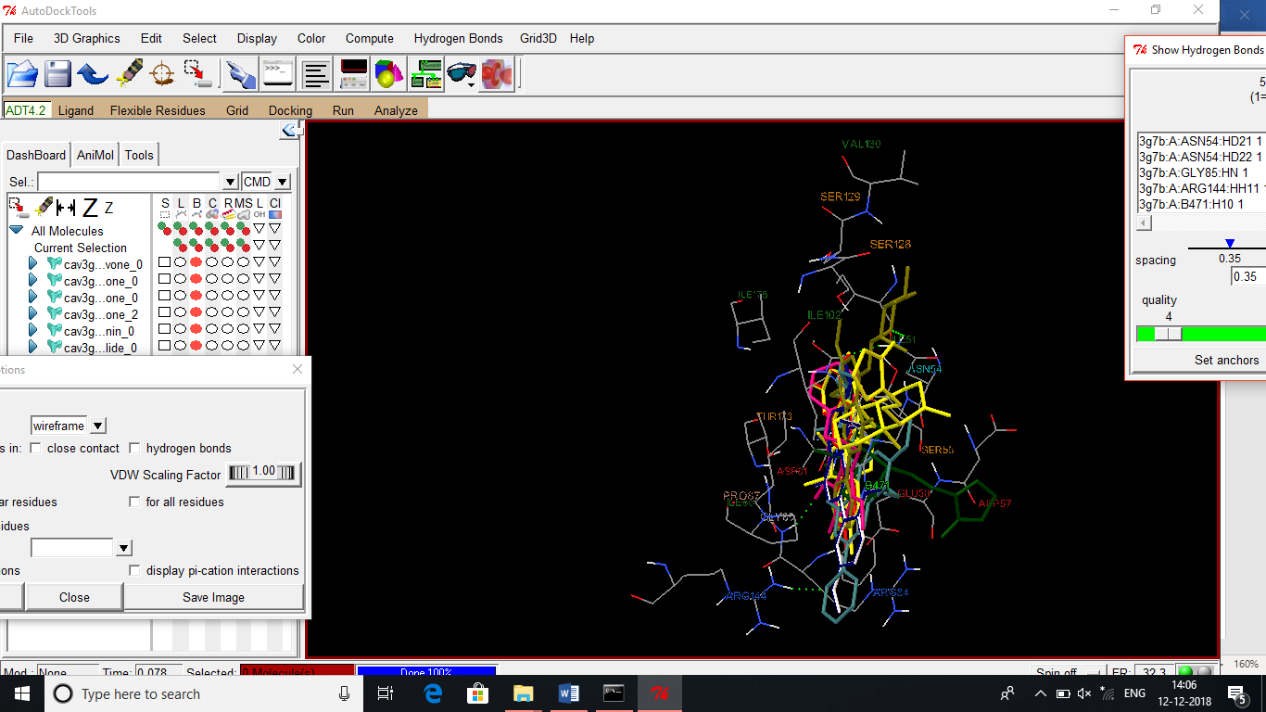
a
Fig 3. Docking interactions of Andrographolide, Andrographidine C, 7-O-methylwogonin, 5,7,3',4'-tetrahydroxyflavone, 5,7,4'-trihydroxyflavone, 7-O-methyldihydrowogonin, Neoandrographolide and 14-Deoxyandrographolide

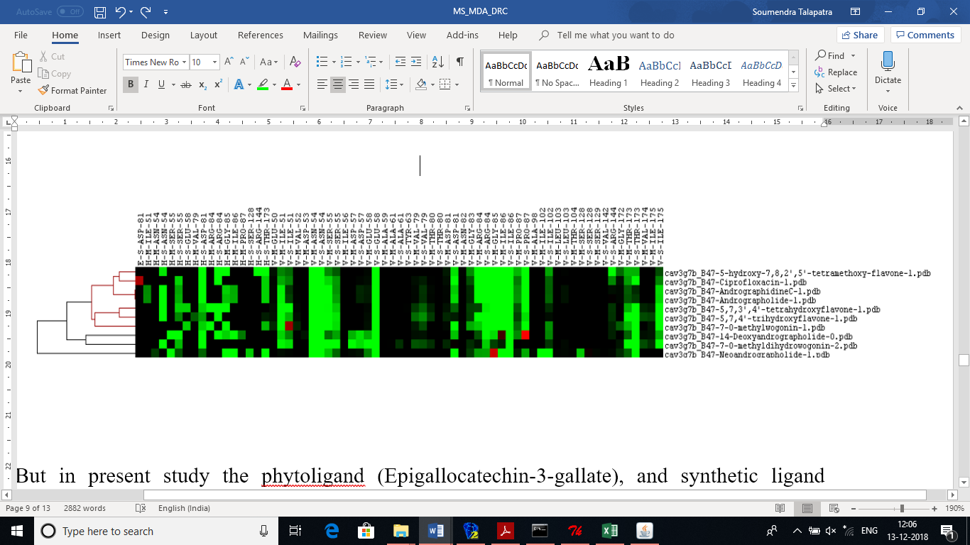
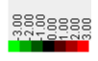
Fig 4.Hierarchical tree representation for the compound similarities using receptor-ligands interaction (Interactions as E = electrostatic; H = hydrogen-bonding and V = vander Waals; M and S = main chain and side chain of the interactingresidue) along with colour code bar value
It was obtained by the present tool a combinatorialcluster analysis and visualize compound candidates generated by virtual screening (VS) through hierarchical tree representation. Basically, clustering steps help to know interaction specific information between target and lead compound(s). The hydrogen bonding value,van der Waal and electrostatic forcesare important in receptor-ligand binding increasing the efficiency of protein-ligand interaction clustering. According to Clinciu et al. (2010)36, the combination of anoptimized docking tool and two clustering stages for thescope of selecting ideal representatives revealed promisingresults.
It was established that the vdW interactions are coloured in green when the energy is less than -4. The hydrogen bonding and electrostatic interactions are coloured in green if the energy is ≤24. M.Hydrogen bonding and van der Waals interactions are the major contributors to compounds recognition in the target -receptor (KandeelandKitade Y, 2013)37.
Conclusion
It is concluded from the computational prediction by molecular docking approach the flavonoidphytoligand5-hydroxy-7,8,2',5'-tetramethoxy-flavonecan be alternative of synthetic antibacterial drug as per binding energy value and interaction of competitive inhibition. According Zhang et al., (2016)38plant derived natural chemical can be suitable as lead compound to prevent synthetic drug resistance of bacteria. This presentin silicostudy is suggested to validate further toxicological and pharmacological assay with thisflavonoid after isolation from medicinal plant (A. paniculata) on different pathogenic bacteria caused plant pathogenicity, which can be prevented bacterial infection on plants without resistance and environmental hazards.
Acknowledgement
The authors convey thanks to the developers of present software used in the predictive study, data bank for protein and phytochemicals.
Conflict of interest
None
References
1. Foster JK, Lentino JR, Strodtman R, DiVincenzo C. Comparison of in vitro activity of quinolone antibiotics and vancomycin against gentamicin- and methicillin-resistant Staphylococcus aureus by time-kill kinetic studies. Antimicrob Agents Chemother, 1986; 30: 823-827.
2. Barrett CT, Barrett JF. Antibacterials: are the new entries enough to deal with the emerging resistance problems? CurrOpinBiotechnol, 2003; 14, 621-626.
3. Umejiego NN, Gollapalli D, Sharling L, Volftsun A, Lu J, Benjamin NN, Stroupe AH, Riera TV, Striepen B, Hedstrom L. Targeting a prokaryotic protein in a eukaryotic pathogen: identification of lead compounds against cryptosporidiosis. Chem Biol, 2008; 15: 70-77.
4. Thirunarayanan A, Raja S, Mohanraj G, Rajakumar P. Synthesis of chiral core based triazole dendrimers with m-terphenyl surface unit and their antibacterial studies. The Royal Society of Chemistry, 2014; 4(79): 41778-41783.
5. P. K. Singha, S. Roy, and S. Dey, “Antimicrobial activity of Andrographis paniculata,” Fitoterapia, vol. 74, no. 7-8, pp. 692–694, 2003.
6. M. R. Zaidan, A.Noor Rain, A. R. Badrul, A. Adlin, A.Norazah, and I. Zakiah, “In vitro screening of five local medicinal plants for antibacterial activity using disc diffusion method,” Tropical Biomedicine, vol. 22, no. 2, pp. 165–170, 2005.
7. S. P. Voravuthikunchai and S. Limsuwan, “Medicinal plant extracts as anti-Escherichia coli O157:H7 agents and their effects onbacterial cell aggregation,” Journal of Food Protection, vol. 69,no. 10, pp. 2336–2341, 2006.
8. Y. Xu, R. L. Marshall, and T. K. S. Mukkur, “An investigation on the antimicrobial activity of Andrographis paniculata extracts and andrographolide in vitro,” Asian Journal of Plant Sciences, vol. 5, no. 3, pp. 527–530, 2006.
9. Jayakumar T, Hsieh C-H, Lee J-J, Sheu J-R. Experimental and Clinical Pharmacology of Andrographis paniculata and Its Major Bioactive Phytoconstituent Andrographolide.Evidence-Based Complementary and Alternative Medicine Volume 2013, Article ID 846740, 16 pages http://dx.doi.org/10.1155/2013/846740
10.Singh A, Khan MMA, Sahu D, Vishwakarma N, Yadav A, Singh AN. Pharmacological and Anti-bacterial Activities of the leaves of Andrographis paniculataNees. Journal of Pharmacognosy and Phytochemistry 2017; 6(3): 418-420.
11. Morris GM, Lim-Wilby M. Molecular docking. Methods Mol Biol, 2008; 443: 365-382 (doi: 10.1007/978-1-59745-177-2_19).
12. Kuntz ID, Blaney JM, Oatley SJ, Langridge R, Ferrin TE. A geometric approach to macromolecule-ligand interactions. J Mol Biol, 1982; 161(2): 269-288.
13. Walters WP, Stahl MT, Murcko MA. Virtual screening - an overview. Drug Discov Today, 1998; 3: 160-178.
14. Bailey D, Brown D. High-throughput chemistry and structure-based design: survival of the smartest. Drug Discov Today, 2001; 6(2): 57-59.
15. Langer T, Hoffmann RD. Virtual screening: an effective tool for lead structure discovery? Curr Pharm Des, 2001; 7(7): 509-527.
16. Bajorath J. Integration of virtual and high-throughput screening. Nat Rev Drug Discov, 2002; 1(11): 882-894.
17. Gohlke H, Klebe G. Approaches to the description and prediction of the binding affinity of smallmolecule ligands to macromolecular receptors. Angew Chem Int Ed Engl, 2002; 41(15): 2644-2676.
18.Jorgensen WL. The many roles of computation in drug discovery. Science, 2004; 303(5665): 1813-1818.
19. Shoichet BK, McGovern SL, Wei B, Irwin JJ. Hits, leads and artifacts from virtual and high throughput screening. Molecular Informatics: Confronting Complexity 2002.
20. Kitchen DB, Decornez H, Furr JR, Bajorath J. Docking and scoring in virtual screening for drug discovery: methods and applications. Nat Rev Drug Discov, 2004; 3(11): 935-949.
21. Moitessier N, Englebienne P, Lee D, Lawandi J, Corbeil CR. Towards the development of universal, fast and highly accurate docking/scoring methods: a long way to go. Br J Pharmacol, 2008; 153(Suppl 1): S7-26.
22. Meng X-Y, Zhang H-X, Mezei M, Cui M. Molecular Docking: A powerful approach for structure-based drug discovery. CurrComput Aided Drug Des, 2011; 7(2): 146-157.
23. de Ruyck J, Brysbaert G, Blossey R, Lensink MF. Molecular docking as a popular tool in drug design, an in silico travel Advances and Applications in Bioinformatics and Chemistry, 2016; 9: 1–11.
24. Yadav D, Talapatra SN, Gupta K, Swarnakar S. Alteration of morphology and constituents of Azadirachtaindica leaf due to air pollution and exploiting the phenomenon for medicinal usage on gastric ulcer through molecular docking. Int J Pharm Sci Rev Res, 2017; 44(2): 103-111.
25. Cozzarelli NR. DNA gyrase and the supercoiling of DNA. Science, 1980; 207: 953-960.
26. Ronkin SM, Badia M, Bellon S, Grillot A-L, Gross CH, Grossman TH, Mani N, Parsons JD, Stamos D, Trudeau M, Wei Y, Charifson PS. Discovery of pyrazolthiazoles as novel and potent inhibitors of bacterial gyrase. Bioorganic and Medicinal Chemistry Letters, 2010; 20(9): 2828-2831.
27. Morris GM, Goodsell DS, Halliday R, Huey R, Hart WE, Belew RK, Olson AJ.Automated docking using a Lamarckian genetic algorithm and an empirical binding free energy function. J Comput Chem, 1998; 19: 1639-1662.
28.Chen LX, Qu GX, Qiu F.Studies on flavonoids of Andrographis paniculata. Zhongguo Zhong Yao Za Zhi. 2006; 31(5): 391-395.
29. JarukamjornK,Nemoto N.Pharmacological aspects of Andrographis paniculata on health and and its major diterpenoid constituent andrographolide. Journal of Health Science 2008; 54(4): 370-381.
30.Chen LX, Qu GX, Qiu F.Studies on flavonoids of Andrographis paniculata. Zhongguo Zhong Yao Za Zhi. 2006; 31(5): 391-395.

31. Yang J-M, and Chen C-C, GEMDOCK: A generic evolutionary method for molecular docking, Proteins: Structure, Function, and Bioinformatics, 55, 2004, 288-304.
32. Gross CH, Parsons JD, Grossman TH, Charifson PS, Bellon S, Jernee J, Dwyer M, Chambers SP, Markland W, Botfield M, Raybuck SA. Active-site residues of Escherichia coli DNA gyrase required in coupling ATP hydrolysis to DNA supercoiling and amino acid substitutions leading to novobiocin resistance. Antimicrobial Agents and Chemotherapy, 2003; 47: 1037-1046.
33. Jagadeesan G, Vijayakuma V, Palayam M, Suresh G, Krishnaswamy G, Aravindhan, S, Peters, GHJ. Pyrazole based inhibitors against enzymes of Staphylococcus aureus: A computational study. J Proteomics Bioinform 2015; 8: 142-148 (doi:10.4172/jpb.1000362).

34. Gradišar H, Pristovšek P, Plaper A, Jerala R. Green tea catechins inhibit bacterial DNA gyrase by interaction with its ATP binding site. Journal of Medicinal Chemistry, 2007; 50: 264-271.
35. Barik P, Talukdar P. (2018). Established phytoligands from Tridaxprocumbens Linn. against bacterial DNA-gyrase B receptor: Molecular docking approach. World Journal of Pharmaceutical Research 7(12): 582-593.
36. Clinciu DL, Chen Y-F, Ko C-N, Lo C-C, Yang J-M.TSCC: Two-Stage Combinatorial Clusteringfor virtual screening using protein-ligandinteractions and physicochemical features. BMC Genomics 2010, 11(Suppl 4):S26.

37. Zang P, Gong A, Zhang P, Yu J. Targeting druggable enzymome by exploiting natural medicines: An in silico–in vitro integrated approach to combating multidrug resistance in bacterial infection, Pharmaceutical Biology, 2016; 54 (4): 604-618.
38.Kandeel M, Kitade Y (2013) Computational analysis of siRNA recognition by the Ago2 PAZ domain and identification of the determinants of RNAinduced gene silencing. PLoS ONE 8(2): e57140. doi:10.1371/journal.pone.0057140

